|  |  |
| --- | --- |
| **Engineering Mathematics and Physics** | **Department** |
| **---------------** | **Division** |
| **2019-2020 Preparatory** | **Academic Year** |
| **Computer** | **Course name** |
| **ECE001** | **Course code** |

**Research project**

**Title:-**

**Build a Simple HTML Website about programming languages**

|  |  |
| --- | --- |
| **Name** | **جنة الله اشرف محمد سعد** |
| **Edu mail** | **ganna195294@feng.bu.edu.eg** |
| **B.N** | **268** |
| **Section** | **12** |
| **Sequence number** | **21** |

**By:**

**Approved by:**

|  |  |
| --- | --- |
| **Examiners committee** | **Signature** |
| **Dr.Ahmed Bayoumi** |  |
| **Dr.Shady Elmashad** |  |
| **Dr.Abdelhamid Attaby** |  |

**GitHup Link:**

**Application Brief:**

Computer programming languages allow us to give instructions to a computer in a language the computer understands. Just as many human-based languages exist, there are an array of computer programming languages that programmers can use to communicate with a computer. The portion of the language that a computer can understand is called a “binary.” Translating programming language into binary is known as “compiling.” Each language, from C Language to Python, has its own distinct features, though many times there are commonalities between programming languages.

These languages allow computers to quickly and efficiently process large and complex swaths of information. For example, if a person is given a list of randomized numbers ranging from one to ten thousand and is asked to place them in ascending order, chances are that it will take a sizable amount of time and include some errors. There are dozens of programming languages used in the industry today. We've compiled overviews of the 12 most important, relevant and in-demand of the languages below.

**Screenshots**

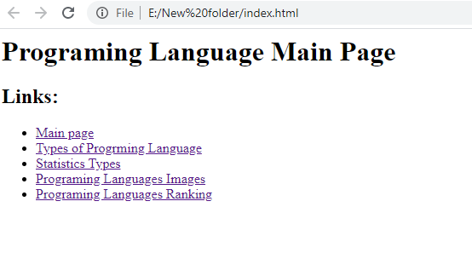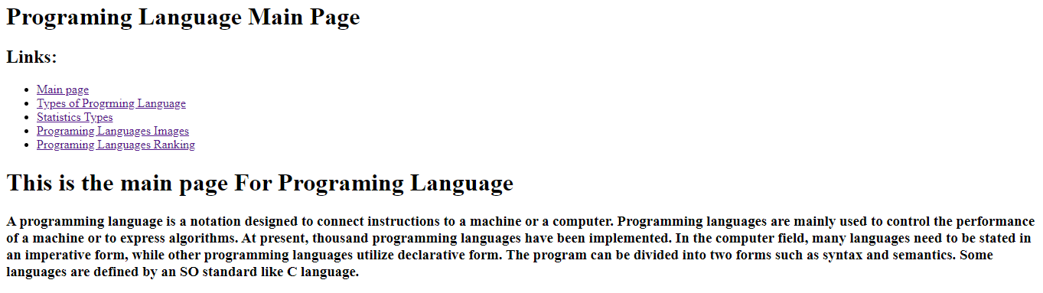

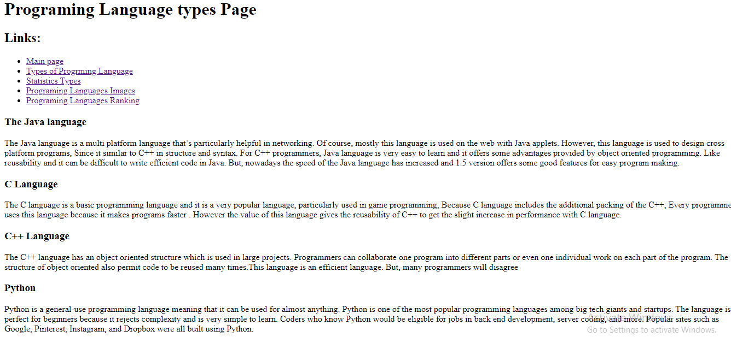

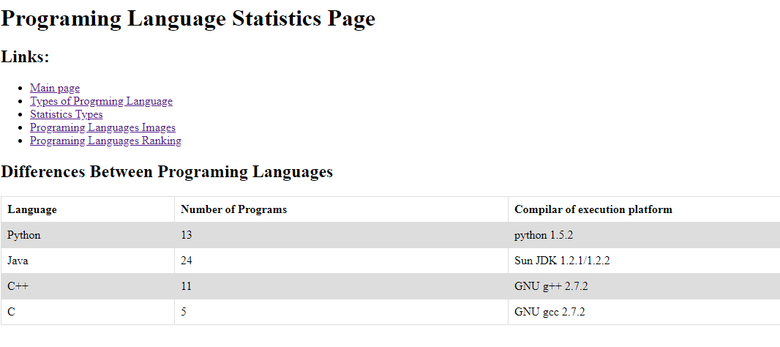

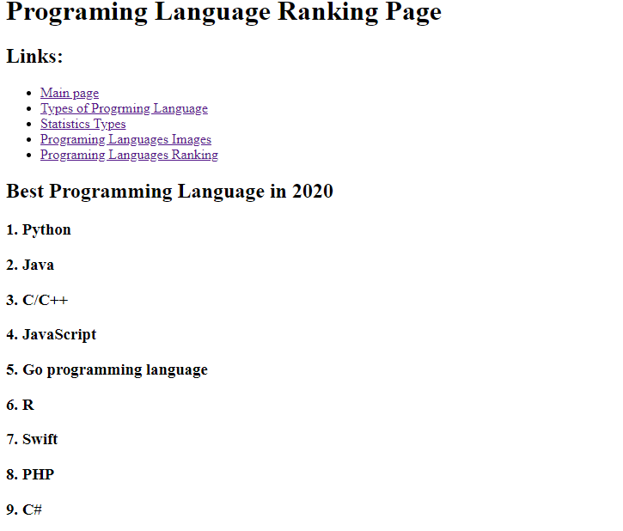

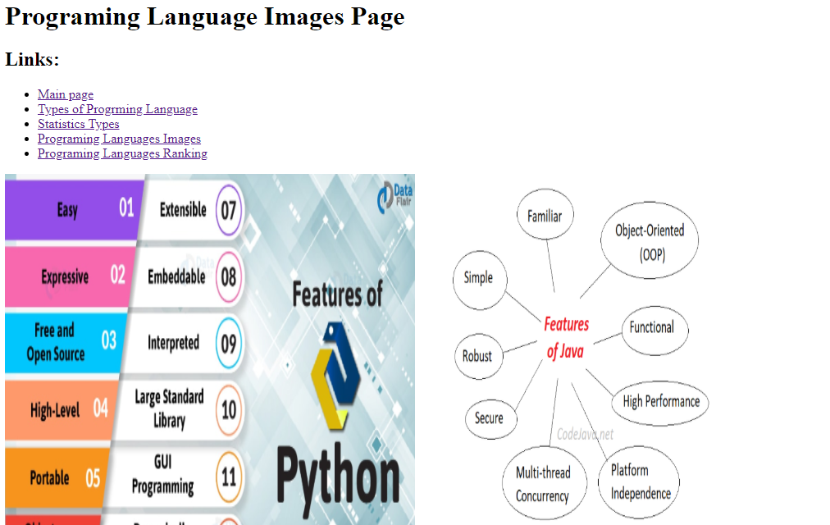

**source code**

